5-1 Project One: Writeup and Screenshots

Andrew Wilson

Computer Science Department, Southern New Hampshire University

CS-340: Client/Server Development

Dr. James O. Webb, Jr.

February 9, 2025

5-1 Project One: Writeup and Screenshots

In this assignment, I wrote a Python CRUD driver class that handles connecting and authenticating to the MongoDB server and database, and provides simple create and find methods. Currently, the methods are very light adapters that simply pass the JSON objects (in Python: dict objects) to the MongoDB server without any validation. Simple error-checking is done on arguments and database operations. Screenshots are shared showing that the AAC database data had been previously imported and showing a test script (in a Jupyter notebook) that uses the CRUD driver to actually create and retrieve a record from the MongoDB database.

**Screenshot 1: Since I previously imported the AAC records into the mongodb database, I verify the records still exist here. I run mongosh, switch to the AAC database, and count all document records to verify all 10,000 from the CSV file have been imported and are still present.**

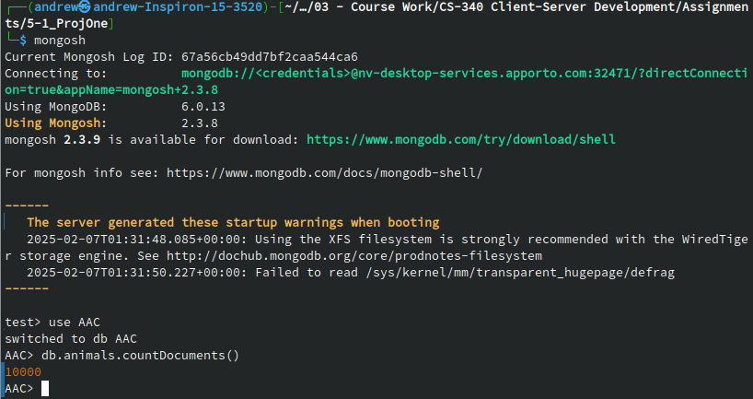

**Screenshot 2: The test script in the Jupyter notebook. This script imports my animal shelter CRUD driver. It create a dictionary object with data for a new record. Then it searches the database looking for a matching record. There should be none that match, since we have not added it yet. Next, we add the record to the database. Since the `create` method returns a boolean indicating whether the creation succeeded, we save the results and check it in an `if` statement. Finally, we search the database for the record we just inserted to verify that it was successfully added.**